

#### A Project Report on

**“A Study on Investigating the Role of Financial Technology (Fintech) In Shaping the Future of Banking.”**

Submitted to:

#### Department Of Management Sciences & Research (DMSR)

**G.S. College of Commerce & Economics, Nagpur (An Autonomous Institution)**

Affiliated to:

#### Rashtrasant Tukadoji Maharaj Nagpur University, Nagpur

In partial fulfilment for the award of the degree of

#### Masters of Business Administration

Submitted by:

#### Miss. Ishika Deepak Chhetri

Under the Guidance of

**Dr. Madhuri V. Purohit**

**Department of Management Sciences & Research**

**G.S. College of Commerce & Economics, Nagpur NAAC Accredited “A” Grade Institution**

**(Academic Year 2023-24)**



**Department of Management Sciences and Research,**

**G.S. College of Commerce & Economics, Nagpur NAAC Accredited “A” Grade Institution**

**Academic Year 2023-24**

## CERTIFICATE

This is to certify that **Miss. Ishika Deepak Chhetri** has submitted the project report titled, **“A Study on Investigating the Role of Financial Technology (Fintech) In Shaping the Future of Banking.”**, under the guidance of **Dr. Madhuri V. Purohit** towards the partial fulfilment of **MASTER OF BUSINESS ADMINISTRATION** degree examination.

It is certified that he/she has ingeniously completed his/her project as prescribed by **DMSR – G.S. College of Commerce & Economics, Nagpur (NAAC Accredited “A” Grade Autonomous Institution)** affiliated to Rashtrasant Tukadoji Maharaj Nagpur University, Nagpur.

**DR. MADHURI V. PUROHIT DR. MADHURI V. PUROHIT**

**(Project Guide) MBA Coordinator**

**Place: Nagpur Date:**



**Department of Management Sciences and Research,**

**G.S. College of Commerce & Economics, Nagpur NAAC Accredited “A” Grade Institution**

**Academic Year 2023-24**

## DECLARATION

I, Ishika Deepak Chhetri here-by declare that the project with title **“A Study on Investigating the Role of Financial Technology (Fintech) In Shaping the Future of Banking.”**, has been completed by me under the guidance of **Dr. Madhuri V. Purohit** in partial fulfilment of **MASTER OF BUSINESS ADMINISTRATION** degree examination as prescribed by **DMSR – G. S. College of Commerce & Economics , Nagpur (NAAC Accredited “A” Grade Autonomous Institution)** affiliated to Rashtrasant Tukadoji Maharaj Nagpur university, Nagpur.

This project was undertaken as a part of academic curriculum and has not been submitted for any other examination and does not form the part of any other course undertaken by me.

#### Place: Nagpur Miss. Ishika Deepak Chhetri Date:



**Department of Management Sciences and Research,**

**G.S. College of Commerce & Economics, Nagpur NAAC Accredited “A” Grade Institution**

**Academic Year 2023-24**

## ACKNOWLEGDEMENT

With immense pride and sense of gratitude, I take this golden opportunity to express my sincere regards to **Dr. Praveen Mastoor**, principal, G. S. College of Commerce & Economics, Nagpur.

I tender my sincere regards to Coordinator, Dr. **Madhuri V. Purohit** for giving me guidance, suggestions and invaluable encouragement which helped me in the completion of the project.

I am extremely thankful to my project guide **Dr. Madhuri V. Purohit** for his/her guideline throughout the project.

I would like to thank **Prof. Uday Dhomne** for his/her constant support & guidance throughout the project.

Last but not the least, I am very thankful to all those who helped me directly and indirectly in successful completion of my project.

**Place: Nagpur Miss. Ishika Deepak Chhetri Date:**



**INDEX**

|  |  |  |
| --- | --- | --- |
| Sr. No | Particulars | Page No. |
| 1. | Introduction | 1-7 |
| 2. | Company Profile | 8-17 |
|  | 2.1 Reserve Bank of India (RBI) |  |
| 3. | Literature Review | 18-21 |
| 4. | Research Methodology | 22-28 |
|  | 4.1 Problem Statement |  |
|  | 4.2 Need of The Study |  |
|  | 4.3 Objectives of The Study |  |
|  | 4.4 Hypothesis of The Study |  |
|  | 4.5 Limitations of The Study |  |
| 5. | Data Analysis & Interpretations | 29-37 |
| 6. | Findings & Suggestions | 38-40 |
| 7. | Conclusion | 41-42 |
| 8. | References | 43-44 |
| 9. | Annexure | 45-49 |



# CHAPTER- 1 INTRODUCTION



## INTRODUCTION

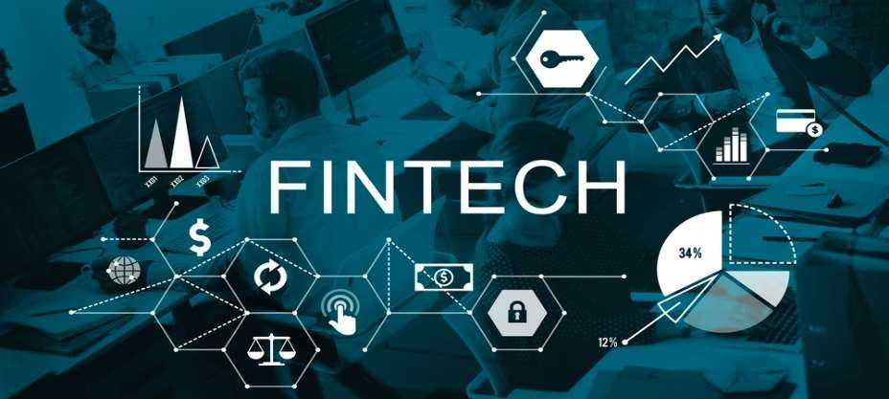

Companies that implement software and computer technology to provide financial services are known as fintech companies, from smartphones to crypto payment apps. Fintech generally refers to transactions involving business-to- business (B2B). Most fintech products are designed to convert customer finances to simple software. Financial services and products have constantly evolved across the globe.”

Therefore, Fintech is viewed as a large and diverse area due to its size and complexity. As part of Fintech, financial changes are described, payment infrastructure is explained, key payment instruments are identified and explained, money flows are understood, and regulatory frameworks are recognized and analyzed to determine whether they hinder or promote innovation. (Kukreja et al., 2020) Artificial intelligence, blockchains, and crypto currencies have all grown in popularity in recent years.

Digitalization has created Neobanks, robotic advisors, and countless other mouthpieces throughout the media. Among the most notable technologies are the



Internet of Things (IoT), Artificial Intelligence (AI), blockchain, and cloud computing.

Customers' communication Innovations change customers' communication with buyers and their money management has disrupted traditional financial investors, but those who have embraced technological advancement are disrupting the industry from the outside. It is for this reason that they are not thriving in traditional markets.

According to Pollari and Raisbeck, “Fintech is today's biggest disruptor in our financial institutions. In our survey, it was ranked number one by 57% of respondents, ahead of emerging global regulatory complexity (51%) and new business models (46%)”. (Raisbeck, 2017) Financial services are being transformed by the FinTech industry.

The user experience and comfort of a product, as well as savings in cost, are all factors that can greatly benefit a customer. As a result, they are now able to access financial services for the first time in history, and that's just the beginning.

In the rapidly evolving landscape of financial services, Financial Technology (Fintech) has emerged as a transformative force, reshaping the future of banking services. This review paper provides a comprehensive analysis of the role of Fintech in revolutionizing traditional banking practices, exploring its impact on customer experiences, financial inclusion, regulatory frameworks, and the overall trajectory of the banking industry.

The review begins by tracing the historical evolution of Fintech and its intersection with traditional banking. It delves into the disruptive technologies driving Fintech innovation, including blockchain, artificial intelligence, and mobile applications, and their transformative effects on the efficiency, accessibility, and scope of banking services.



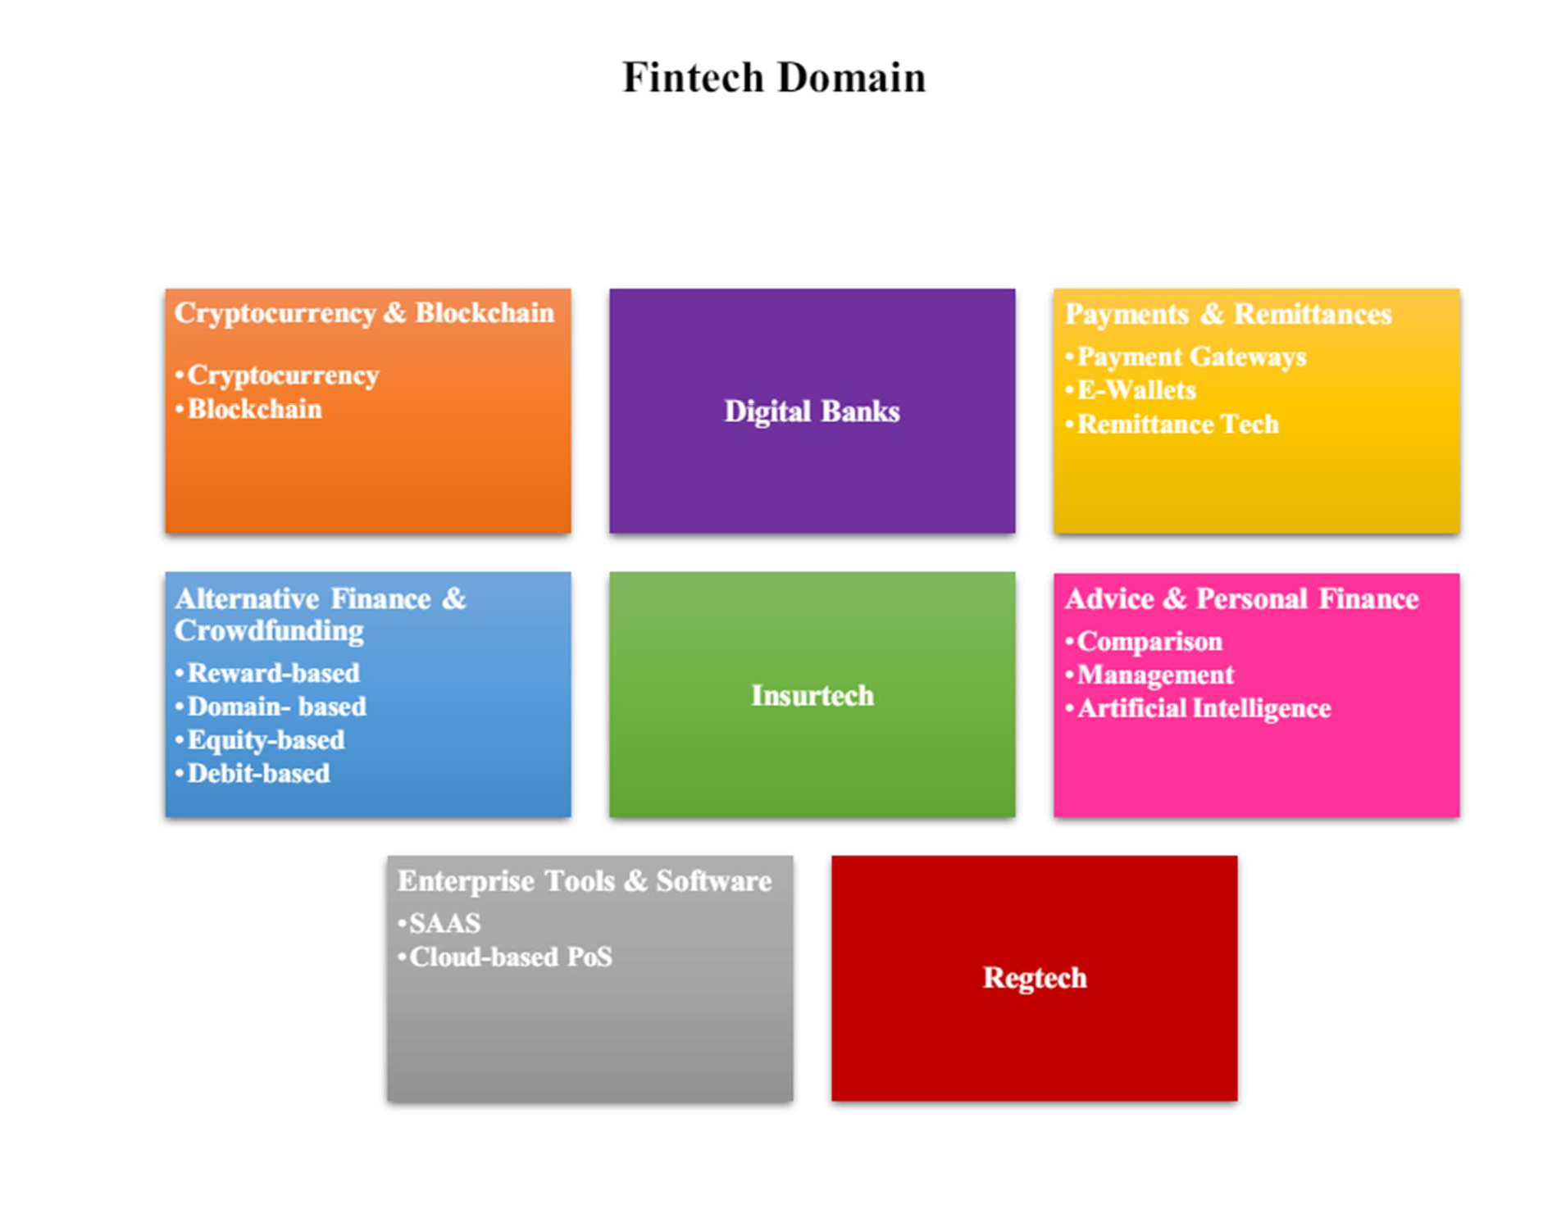

While Fintech promotes financial inclusion, creates more jobs, encourages innovation, and makes financial services more accessible, it also opens people, frameworks, and governments to emerging threats that could disrupt the proper functioning of activities and existing policies. Fintech offers more efficient and convenient payment choices, but it also introduces new concerns in terms of competition, privacy, and financial stability. As a result, many people are concerned about privacy issues, system dependability, cybersecurity, and potential vulnerability to cyber-attacks. The financial and monetary authorities are actively evaluating this digital innovation in terms of impact, benefits, and threats to avoid risks from materializing. They are introducing new regulatory policies to reflect the most recent events in the financial service industry. Several



financial institutions are concurrently examining various variations of central bank digital currency (CBDC).

Furthermore, the paper analyzes the influence of Fintech on customer experiences, emphasizing the shift towards digital platforms, personalized services, and real-time transactions. It explores how Fintech has democratized financial services, enabling broader access to banking solutions and fostering financial inclusion, particularly in underserved populations. The regulatory landscape is a critical focus of this review, examining how authorities are adapting to the dynamic nature of Fintech. It scrutinizes the challenges and opportunities posed by regulatory frameworks, highlighting the need for balance between innovation facilitation and risk management.

Moreover, the paper investigates the emergence of new banking models such as neobanks and the collaborative relationships between traditional banks and Fintech startups. It explores how these partnerships have synergized to offer innovative solutions while navigating challenges related to competition, data security, and regulatory compliance. The paper concludes by forecasting the future trajectory of banking services in the era of Fintech dominance. It discusses the potential impact on job roles, business models, and the overall stability of the financial system, emphasizing the imperative for continuous adaptation and collaboration in this dynamic ecosystem.

This paper provides valuable insights into the multifaceted role of Fintech in shaping the future of banking services, offering a holistic perspective on the opportunities, challenges, and transformative potential of this technological revolution. The banking landscape has undergone a transformative evolution in recent years, driven by the relentless march of financial technology, or Fintech. The convergence of cutting-edge technologies and financial services has ushered in a new era, fundamentally reshaping the way banking services are conceptualized, delivered, and experienced.



This review explores the pivotal role of Fintech in THE ROLE OF FINTECH IN SHAPING THE FUTURE OF BANKING SERVICES 188 shaping the future of banking services, unraveling the multifaceted impacts and transformative potential that have positioned Fintech as a driving force in the financial sector. The emergence of Fintech has disrupted traditional banking paradigms, challenged established norms and fostered an environment of innovation and competition.

As a fusion of technology and finance, Fintech encompasses a diverse range of services, including digital payments, peer-to-peer lending, robo-advisors, blockchain-based solutions, and mobile banking applications. These innovations have not only revolutionized the customer experience but have also engendered a seismic shift in the operational frameworks of financial institutions. One of the key areas where Fintech has exerted its influence is in enhancing financial inclusion.

The ubiquity of smartphones and the democratization of access to financial services have empowered individuals previously excluded from traditional banking systems. Fintech has pioneered solutions that transcend geographical barriers, providing the unbanked and underbanked populations with unprecedented access to essential financial tools and services.

Moreover, the review delves into the impact of Fintech on the efficiency and cost-effectiveness of banking operations. Automation, artificial intelligence, and data analytics have streamlined processes, reduced operational costs and enhanced the speed and accuracy of financial transactions. This efficiency dividend has not only benefited financial institutions but has also translated into improved services for customers.

In addition to exploring the positive aspects, this review critically assesses the challenges and risks associated with the integration of Fintech in banking services. Issues such as data security, regulatory frameworks, and the potential concentration of financial power are examined to provide a balanced



understanding of the Fintech-driven banking landscape. As we stand on the precipice of a banking revolution, understanding the intricate dynamics between Fintech and traditional banking becomes imperative.

This review contributes to the ongoing discourse by synthesizing existing knowledge, offering insights into the transformative potential of Fintech, and paving the way for informed discussions on the future trajectory of banking services.

Fintech, a clipped compound of “Financial Technology”, refers to firms using new technology to compete with traditional financial methods in the delivery of financial services. The use of smartphones for mobiles banking, investing, borrowing services and cryptocurrency are examples of technologies designed to make financial services more accessible to the general public. Fintech companies consist of both startups and established financial institutions and technology companies trying to replace or enhance the usage of financial services provided by existing financial companies.

Fintech, short for financial technology, refers to the integration of technology into offerings by financial services companies in order to improve their use and delivery to consumers. This can encompass a wide array of innovations, including mobile banking apps, peer-to-peer lending platforms, robot-advisors for investment management, blockchain and cryptocurrency applications, and much more.

Financial inclusion is the availability and equality of opportunities to access financial services. It refers to a process by which individuals and businesses can access appropriate, affordable, and timely financial products and services which include banking, loan equity, and insurance products. It is apath to enhance inclusiveness in economic growth by enabling the unbanked population to access the means for savings, investment, and insurance towards improving household income and reducing income inequality.



# CHAPTER-2 COMPANY PROFILE



## RESERVE BANK OF INDIA

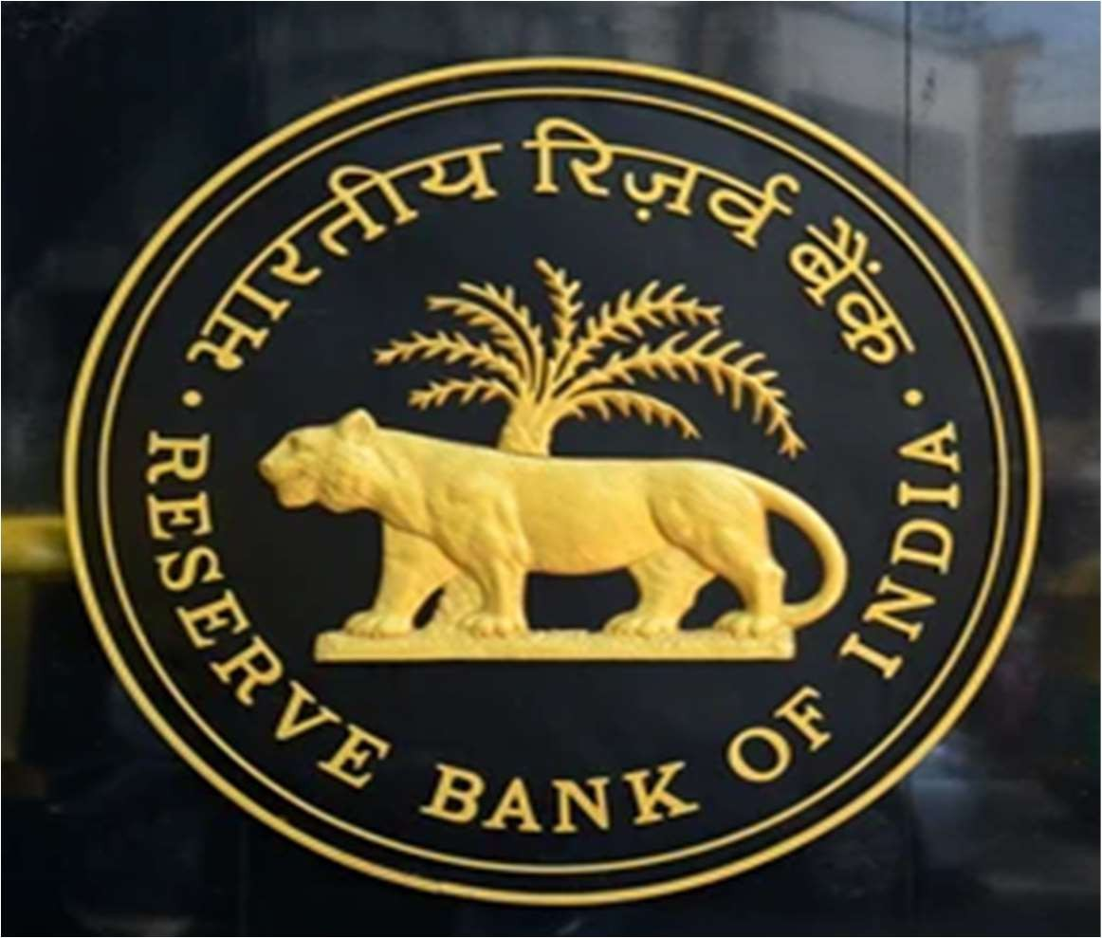

The Reserve Bank of India, abbreviated as RBI, is India's central bank and regulatory body responsible for regulation of the Indian banking system. Owned by the Ministry of Finance, Government of India, it is responsible for the control, issue and maintaining supply of the Indian rupee.

RBI regulates issue of bank notes and keeping of reserves to ensure monetary stability, formulates monetary policy, issues government securities and undertakes financial supervision of commercial banks, financial institutions and non-banking financial companies.

**RBI consists of the following members:**

* **One**- Governor
* **Four**- Deputy Governor
* **Fourteen**- Directors
* **Two**- Government Office



**KEY INFORMATION:**

**PROFILE**

**HEADQUARTER** MUMBAI, INDIA

**ESTABLISHED** 1 APRIL, 1935

**GOVERNOR** SHAKTIKANTA DAS

**CENTRAL BANK** INDIA

**CURRENCY** INDIAN RUPEE

**BANK RATE** 6.75%

**JURISDICTION** GOVERNMENT OF INDIA

**WEBSITE** *https://*[*www.rbi.org.in*](http://www.rbi.org.in/)



## RBI GOVERNORS LIST FROM 1935 TO 2022

The list of RBI’s Governors from 1935 to 2022 is as mentioned below:

|  |  |
| --- | --- |
| R**BI Governors Names Time Period 1935-2022** | |
| **Sir Osborne Smith** | April 1, 1935 – June 30, 1937 |
| **Sir James Braid Taylor** | July 1, 1937 – February 17, 1943 |
| **Sir C.D. Deshmukh** | August 11, 1943 – June 30, 1949 |
| **Sir Bengal Rama Rau** | July 1, 1949 – January 14, 1957 |
| **K.G. Ambegaonkar** | January 14, 1957 – February 28, 1957 |
| **H.V.R Lyengar** | March 1, 1957 – February 28, 1962 |
| **P.C Bhattacharya** | March 1, 1962 – June 30, 1967 |
| **L.K. Jha** | July 1, 1967 – May 3, 1970 |
| **B.N. Adarkar** | May 4, 1970 – June 15, 1970 |
| **S. Jagannathan** | June 16, 1970 – May 19, 1975 |
| **N.C. Sen Gupta** | May 19, 1975 – August 19, 1975 |
| **K.R. Puri** | August 20, 1975 – May 2, 1977 |
| **M. Narasimham** | May 3, 1977 – November 30, 1977 |



|  |  |
| --- | --- |
| **I.G. Patel** | December 1, 1977 – September 15, 1982 |
| **Manmohan Singh** | September 16, 1982 – January 14, 1985 |
| **Amitav Gosh** | January 15, 1985 – September 4, 1985 |
| **R.N. Malhotra** | February 4, 1985 – December 22, 1990 |
| **S. Vpnldraramanan** | December 22, 1990 – December 21, 1992 |
| **C. Rangarajan** | December 22, 1992 – November 21, 1997 |
| **Bimal Jalan** | November 22, 1997 – September 6, 2003 |
| **Y.V. Reddy** | September 6, 2003 – September 5, 2008 |
| **D. Subbarao** | September 5, 2008 – September 4, 2013 |
| **Raghuram G. Raj an** | September 4, 2013 – September 4, 2016 |
| **Urjit Ravindra Patel** | September 4, 2016 – December 10,2018 |
| **Shaktikanta Das** | December 12, 2018 – to date |



## MISSION & VISION STATEMENT OF RBI

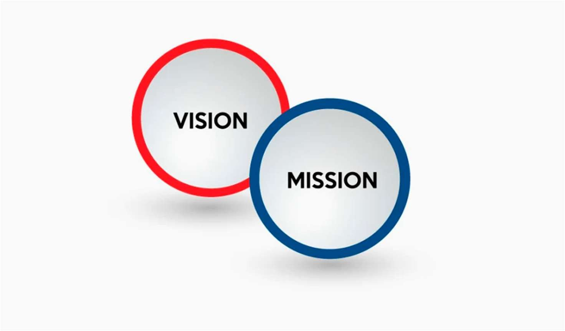

**MISSION STATEMENT**

RBI is recognized as the industry standard for small business entrepreneurial training, resulting in a positive impact on the prosperity of the participant’s family, the community and the overall economy.

## VISION STATEMENT

To develop successful entrepreneurs through experience-based training and mentoring of RBI fellows.

The overall direction of the RBI lies with the 21-member central board of directors, composed of: the governor; four deputy governors; two finance ministry representatives (usually the Economic Affairs Secretary and the Financial Services Secretary); ten government-nominated directors; and four directors who represent local boards for Mumbai, Kolkata, Chennai, and Delhi. Each of these local boards consists of five members who represent regional interests and the interests of co-operative and indigenous banks.



## ROLE OF RESERVE BANK OF INDIA

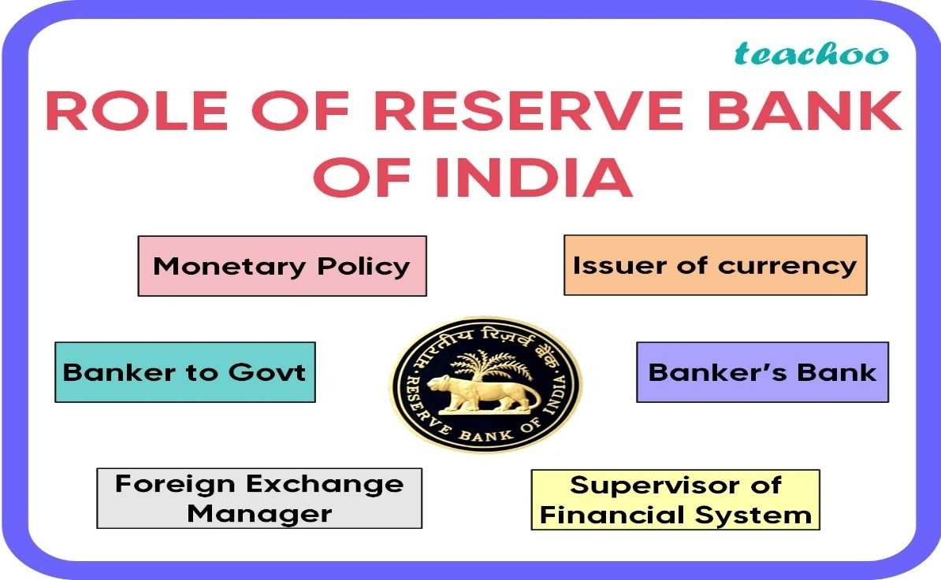

### MONETORY POLICY

one of its primary functions is to formulate and implement monetary policy. This includes setting key interest rates like the repo rate, which influences borrowing costs for banks and, ultimately, for consumers and businesses. The RBI aims to maintain price stability while also supporting economic growth.

### BANKER TO GOVERNMENT

The RBI acts as the banker, agent, and advisor to the Government of India and state governments. It manages their accounts, facilitates government borrowing through the issuance of bonds and treasury bills, and implements monetary policies in coordination with fiscal policies.

### FOREIGN EXCHANGE MANAGER

The RBI manages India's foreign exchange reserves, which include foreign currencies, gold, and other assets. These reserves are crucial for



maintaining stability in the external value of the Indian rupee and meeting international payment obligations.

### ISSUER OF CURRENCY

The RBI has the sole authority to issue currency notes except for the one rupee note and coins, which are issued by the Government of India. It manages the supply and distribution of currency throughout the country to ensure smooth transactions and prevent counterfeiting.

### BANKER’S BANK

The RBI acts as the banker, agent, and advisor to the Government of India and state governments. It manages their accounts, facilitates government borrowing through the issuance of bonds and treasury bills, and implements monetary policies in coordination with fiscal policies.

### SUPERVISION OF FINANCIAL SYSTEM

The RBI promotes the development of financial markets and institutions by introducing policies and initiatives to enhance financial inclusion, deepen financial markets, and foster innovation in the financial sector. It also undertakes various developmental activities aimed at supporting priority sectors of the economy.



**FINANCIAL SUPERVISION**

The primary objective of RBI is to undertake consolidated supervision of the financial sector comprising commercial banks, financial institutions, and non- banking finance companies.

The board is constituted by co-opting four directors from the Central Board as members for a term of two years and is chaired by the governor. The deputy governors of the reserve bank are ex-officio members. One deputy governor, usually the deputy governor in charge of banking regulation and supervision, is nominated as the vice-chairman of the board. The board is required to meet normally once every month. It considers inspection reports and other supervisory issues placed before it by the supervisory departments.

Board for Financial Supervision (BFS) through the Audit Sub-Committee also aims at upgrading the quality of the statutory audit and internal audit functions in banks and financial institutions. The audit sub-**committee** includes deputy governor as the chairman and two directors of the Central Board as members. The BFS oversees the functioning of the Department of Banking Supervision (DBS), the Department of Non-Banking Supervision (DNBS) and the Financial Institutions Division (FID) and gives directions on the regulatory and supervisory issues.



### FUNCTIONS OF RBI

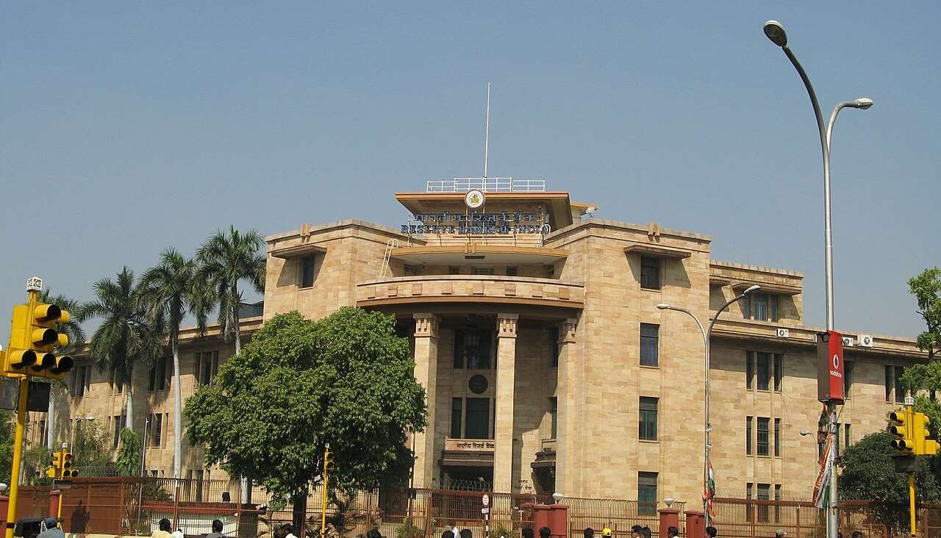

The central bank of any country executes many functions such as overseeing monetary policy, issuing currency, managing foreign exchange, working as a bank for government and as a banker of scheduled commercial banks. It also works for overall economic growth of the country. The purposes for which the RBI has been established as India’s central bank has been spelt out in the preamble to the RBI Act

* 1. “To regulate the issue of banknotes and the keeping of reserves with a view to securing monetary stability in India and generally to operate the currency and credit system of the country to its advantage; and
  2. that it is essential to have a modern monetary policy framework to meet the challenge of an increasingly complex economy and the primary objective of the monetary policy is to maintain price stability while keeping in mind the objective of growth” ...to regulate the issue of Bank Notes and keeping of reserves .



# CHAPTER-3 LITERATURE REVIEW



## LITERATURE REVIEW

**"The Rise of FinTech: A New Catalyst for Innovation in Financial Services"** (Gai, Lee, Lu, 2018): This paper provides an overview of the emergence of Fintech and its impact on traditional banking. It discusses how Fintech startups are disrupting the financial industry by offering innovative solutions in payments, lending, and wealth management. The authors also explore the regulatory challenges and opportunities associated with Fintech adoption.

**Fintech and the Transformation of Financial Services: A Survey"** (Claessens, Kodres, 2014): Claessens and Kodres examine the various aspects of Fintech and its implications for financial services. The survey covers topics such as peer-to- peer lending, mobile payments, blockchain technology, and robo-advisors. The authors discuss how Fintech is reshaping the competitive landscape of banking and the potential benefits and risks involved.

**The Impact of Fintech on Banking Structure and Competition"** (De Filippi, Hassan, 2016): This paper analyzes the impact of Fintech on banking structure and competition. De Filippi and Hassan argue that Fintech firms are challenging traditional banks by offering lower costs, greater convenience, and enhanced customer experiences. The authors also discuss the regulatory responses to Fintech innovation and the implications for financial stability.



**Digital Disruption: How FinTech is Forcing Banking to a Tipping Point"** (Bussmann, Moazed, 2015): Bussmann and Moazed explore the concept of digital disruption in the banking industry caused by Fintech innovation. The paper discusses how Fintech startups are leveraging technology to address inefficiencies in traditional banking services and capture market share. The authors highlight the importance of collaboration between banks and Fintech firms to drive innovation and maintain competitiveness.

**Blockchain and Financial Market Innovation: A Review"** (Catalini, Gans, 2016): Catalini and Gans provide a comprehensive review of blockchain technology and its potential applications in financial markets. The paper discusses how blockchain can streamline processes such as cross-border payments, securities trading, and smart contracts. The authors also examine the challenges and regulatory considerations associated with blockchain adoption in banking.

**The Future of FinTech: Integrating Finance and Technology in Financial Services"** (Mistry, 2020): Mistry explores the future of Fintech and its role in integrating finance and technology in financial services. The paper discusses emerging trends such as artificial intelligence, big data analytics, and the Internet of Things in Fintech innovation. The author argues that collaboration between traditional banks and Fintech startups is essential for driving digital transformation in the financial industry.



**The Financial Stability Board (2017)** hinted at certain pieces of evidence that FinTech activities may intensify risk contagion and asset volatility in the financial system, which may be detrimental to financial stability. A number of these studies acknowledge the potential risks posed by FinTech institutions to traditional financial institutions and even to the financial system as a whole. However, their views are not supported by empirical evidence from existing studies, commercial banks can benefit from the technology spillover effect by leveraging FinTech innovations. A key component of this is the optimization of operating performance and the improvement of risk control capabilities.

**Petter and Dean 2009; Shen and Pin 2015** Fintech and banking risks are becoming more prevalent, but existing research still leaves room for expansion. First, existing research focuses more on the impact of online financial development than on the impact of financial technology. 16 The development of FinTech is mainly divided into the Fintech-IT phase (Fintech version 1.0), the Internet finance phase (Fintech version 2.0), and the Fintech phase (Fintech version 3.0). Internet finance is version 2.0 of Fintech (1990-2010), which mainly utilizes Internet technology in the field of financial services, and is a "scale-driven financial model.

.



# CHAPTER-4 RESEARCH METHODOLOGY



## RESEARCH METHODOLOGY

A research methodology describes the techniques and procedures used to identify and analyze information regarding a specific research topic. It is a process by which researchers design their study so that they can achieve their objectives using the selected research instruments. It includes all the important aspects of research, including research design, data collection methods, data analysis methods, and the overall framework within which the research is conducted. While these points can help you understand what is research methodology, you also need to know why it is important to pick the right methodology.

### RESEARCH DESIGN-

The purpose of this study is to gain knowledge and brief understanding about conducting surveys or interviews with banking professionals and customers to gather qualitative data on their experiences and perceptions of fintech.

### RESEARCH APPROACH –

This approach would allow us to identify the strengths and weaknesses of each model and assess the impact of fintech on the banking industry as a whole.

### RESEARCH INSTRUMENT-

Interviewing the customers personally and studying the response from the questionnaires field.

### DATA ANALYSIS METHOD-

The data analysis of this research was represented on qualitative as well as quantitative manner.



### DATA COLLECTION-

* **PRIMARY DATA –**

Primary data refers to original data collected firsthand by the researcher for a specific research purpose. This data is gathered through methods such as surveys, interviews, observations, experiments, and focus groups.

For my research project Questionnaire for in - depth discussion with various respondents to be interviewed through face-to-face contact with respondents as well as through google form during primary survey.

* **SECONDARY DATA –**

Secondary data refers to existing data that has been collected by someone else for a purpose other than the current research study. For my research project Secondary data from various magazine, newspaper, books, journals, government publications, databases, websites, and other prominent source of information collected from different website and search engines.



## PROBLEM STATEMENT

* + - The primary objective of this study is to comprehensively examine the role of Fintech in shaping the future of banking, exploring its impact on various aspects such as customer experience, operational efficiency, risk management, regulatory compliance, and overall industry dynamics.
    - As financial technology (Fintech) continues to evolve at a rapid pace, its impact on the banking sector is becoming increasingly significant.
    - Analyzing current trends, emerging technologies, adoption patterns, and regulatory frameworks, this research aims to provide valuable insights into how banks can effectively leverage Fintech to stay competitive, enhance customer.



## NEED OF THE STUDY

* + - "This study explores how fintech is transforming banking and provides insights for the future."
    - "This study delves into the impact of fintech on banking, shaping its future landscape."

## OBJECTIVES OF THE STUDY

* + - To investigate the role of financial technology (fintech) in shaping the future of banking.
    - To analyze the impact of fintech on enhancing customer experience in the banking industry.
    - To explore the potential of fintech in improving financial inclusion and accessibility for underserved populations.
    - To assess the challenges and opportunities of implementing fintech solutions in traditional banking systems.



## HYPOTHESIS

#### (H0) – Null Hypothesis: -

* Financial technology (fintech) has no significant impact on shaping the future of banking.

#### (H1)-Alternative Hypothesis: -

* Financial technology (fintech) significantly influences the future of banking by reshaping traditional banking practices and services.

#### (H0) – Null Hypothesis: -

* (Fintech) does not improve customer experience and fails to have financial inclusion.

#### (H2) - Alternative Hypothesis: -

* (Fintech) does improve Cluster experience and financial inclusion.



## LIMITATIONS

* + - It has rapid evolution and fintech innovations evolve quickly, making it challenging to predict long-term impacts accurately.
    - Improved customer experience may rely heavily on technological infrastructure, which could exclude segments with limited access to technology or digital literacy.
    - Certain underserved populations may have cultural or trust barriers to adopting fintech solutions, limiting their effectiveness.
    - Integrating fintech solutions with existing banking systems can be complex and costly, leading to implementation challenges.



# CHAPTER-5

**Data Analysis & Interpretations**



1. Age group

|  |  |  |
| --- | --- | --- |
| **AGE GROUP** | **RESPONDENTS** | **PERCENTAGE** |
| Below 18 | 10 | 10% |
| 18-25 | 40 | 40% |
| 26-35 | 20 | 20% |
| 36-45 | 20 | 20% |
| 45 Above | 10 | 20% |
| **TOTAL** | **100** | **100** |



**age group**

below 18 18-25 26-35 36-45 45 above

### INTERPRETATION:

From the above pie-chart it is analyzed that, 10% of the respondents are below age group below 18, 40% of the respondents are below age group of 18-25, 20% of the respondents are below age group of 26-35, 20% of the respondents are below age of age 36-45 and 10% respondents are above age 45.



**familiar with fintech**

**10%**

**30%**

**20%**

not familiar

somewhat familiar

moderately familiar

**40%**

very familiar

1. How familiar are you with the concept of Fintech?

|  |  |  |
| --- | --- | --- |
| **OPTIONS** | **RESPONDENTS** | **PERCENTAGE** |
| Not familiar at all | 10 | 10% |
| Somewhat familiar | 20 | 20% |
| Moderately familiar | 40 | 40% |
| Very familiar | 30 | 30% |

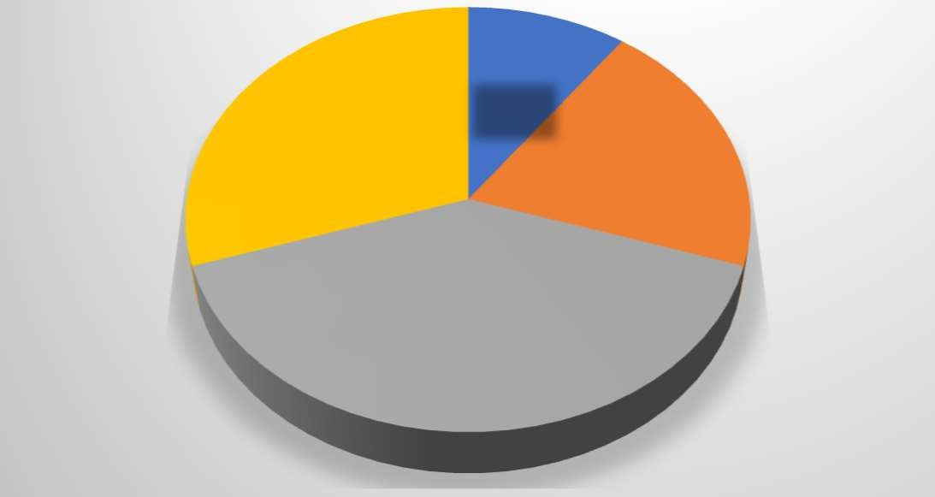

### INTERPRETATION:

From the above data it is analyzed that 10% respondents are not familiar with the fintech, 20% respondents are somewhat familiar with fintech, 40% respondents are moderately familiar and 30% respondents are very familiar with fintech.



**fintech services**

daily

**35%**

**15%**

**10%**

**10%**

**0%**

**40%**

weekly

monthly rarely

never

1. How often do you use Fintech Services (e.g., mobile banking apps, online payment platforms)?

|  |  |  |
| --- | --- | --- |
| **OPTIONS** | **RESPONDENTS** | **PERCENTAGE** |
| Daily | 40 | 40% |
| Weekly | 35 | 35% |
| Monthly | 15 | 15% |
| Rarely | 10 | 10% |
| Never | 0 | 0 |



### INTERPRETATION:

Above data said that a significant proportion of respondents (40%) use Fintech services daily, another substantial group (35%) utilizes Fintech services on a weekly basis, minority (10%) of respondents rarely use Fintech services and notably, there are no respondents who never use Fintech services.



1. What factors would motivate you to use Fintech services over traditional banking services?

|  |  |  |
| --- | --- | --- |
| **OPTIONS** | **RESPONDENTS** | **PERCENTAGE** |
| Convenience | 30 | 30% |
| Lower fees | 10 | 10% |
| Faster transaction processing | 10 | 10% |
| Better user experience | 30 | 30% |
| Trust in technology | 20 | 20% |



**traditional services**

Convenience

Lower fees

Faster transaction processing Better user experience

Trust in technology

### INTERPRETATION:

Hence there are 30% respondents are convenience to use fintech services over traditional banking services, 10% respondents use fintech services over traditional banking services because of lower fees, 10% respondents use it because of its faster transaction processing services, 30% respondents use it because of its better user experience, 20% respondents use it because of its trust in technology.



**fintech services**

**10%**

**15%**

Security and privacy issues

**25%**

**10%**

Lack of human resources

Reliability of technology Complexity of technology Regulatory concerns

**40%**

1. What concerns do you have, if any about using Fintech services?

|  |  |  |
| --- | --- | --- |
| **OPTIONS** | **RESPONDENTS** | **PERCENTAGE** |
| Security and privacy issues | 15 | 15% |
| Lack of human resources | 10 | 10% |
| Reliability of technology | 40 | 40% |
| Complexity of technology | 25 | 25% |
| Regulatory concerns | 10 | 10% |



### INTERPRETATION:

According to survey 15% people have security and privacy issues,10% people have lack of human resources,40% people have reliability of technology ,25% people have complexity of technology,10% people have regulatory concerns.



satisfaction

Very satisfied

Somewhat satisfied neuttral

Somewhat dissatisfied Very dissatisfied

1. How satisfied are you with the current baking services available to you?

|  |  |  |
| --- | --- | --- |
| **OPTIONS** | **RESPONDENTS** | **PERCENTAGE** |
| Very satisfied | 40 | 40% |
| Somewhat satisfied | 20 | 20% |
| Neutral | 25 | 25% |
| Somewhat dissatisfied | 10 | 10% |
| Very dissatisfied | 5 | 5% |

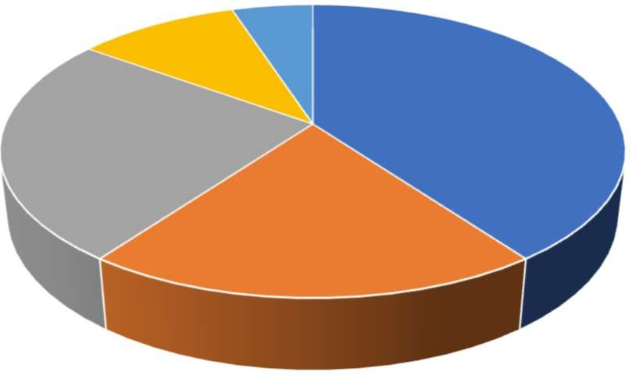

### INTERPRETATION:

Based on the survey data 40% are very satisfied with the current banking services, 20% are somewhat satisfied, 25% are neutrally satisfied, 10% are somewhat dissatisfied and 5% very dissatisfied.



1. Have you ever experienced any security breaches of fraud while using Fintech services?

|  |  |  |
| --- | --- | --- |
| **OPTIONS** | **RESPONDENTS** | **PERCENTAGE** |
| Yes | 20 | 20% |
| No | 80 | 80% |



**breaches of fraud**

yes no

### INTERPRETATION:

According to the survey findings 20% respondents are saying yes about breaches of fraud while using fintech services and 80% respondents are saying no.



1. What factors influence your decision to adopt Fintech services?

|  |  |  |
| --- | --- | --- |
| **OPTIONS** | **RESPONDENTS** | **PERCENTAGE** |
| Convenience | 20 | 20% |
| Cost effectiveness | 10 | 10% |
| Security | 20 | 20% |
| Innovation | 30 | 30% |
| Trust in technology | 20 | 20% |

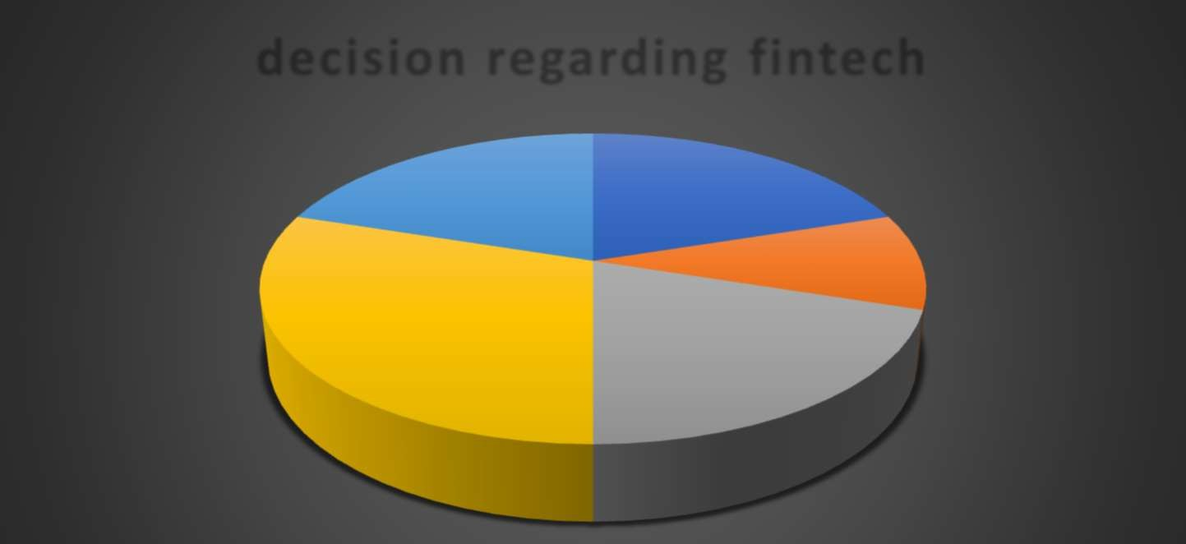

**decision regarding fintech**

Convenience Cost effectiveness Security Innovation Trust in technology

### INTERPRETATION:

According to the survey 20% prioritize convenience when deciding to adopt Fintech services, 10% consider cost effectiveness as a key factor, 20 % respondents are primarily concerned with security, 30 % respondents are driven by innovation, 20% respondents base their decision on trust in technology.



# CHAPTER-6 FINDINGS & SUGGESTIONS



## FINDINGS

* + From the above pie-chart it is analyzed that, 10% of the respondents are below age group below 18, 40% of the respondents are below age group of 18-25, 20% of the respondents are below age group of 26-35, 20% of the respondents are below age of age 36-45 and 10% respondents are above age 45.
  + From the above data it is analyzed that 10% respondents are not familiar with the fintech, 20% respondents are somewhat familiar with fintech, 40% respondents are moderately familiar and 30% respondents are very familiar with fintech.
  + Above data said that a significant proportion of respondents (40%) use Fintech services daily, another substantial group (35%) utilizes Fintech services on a weekly basis, minority (10%) of respondents rarely use Fintech services and notably, there are no respondents who never use Fintech services.
  + Hence there are 30% respondents are convenience to use fintech services over traditional banking services, 10% respondents use fintech services over traditional banking services because of lower fees, 10% respondents use it because of its faster transaction processing services, 30% respondents use it because of its better user experience, 20% respondents use it because of its trust in technology.
  + According to survey 15% people have security and privacy issues,10% people have lack of human resources,40% people have reliability of technology ,25% people have complexity of technology,10% people have regulatory concerns.
  + Based on the survey data 40% are very satisfied with the current banking services, 20% are somewhat satisfied, 25% are neutrally satisfied, 10% are somewhat dissatisfied and 5% very dissatisfied.
  + According to the survey findings 20% respondents are saying yes about breaches of fraud while using fintech services and 80% respondents are saying no.



* + According to the survey 20% prioritize convenience when deciding to adopt Fintech services, 10% consider cost effectiveness as a key factor, 20 % respondents are primarily concerned with security, 30 % respondents are driven by innovation, 20% respondents base their decision on trust in technology.



# CHAPTER-7 CONCLUSIONS



### CONCLUSIONS

Fintech is undeniably reshaping the banking industry, driving a shift towards more efficient, inclusive, and customer-friendly financial services. As the landscape continues to evolve, the synergy between traditional banking and Fintech will be pivotal in creating a dynamic and resilient financial ecosystem. Future research should continue to explore the long-term impacts of Fintech on financial markets, customer behavior, and global economic trends, ensuring that stakeholders can navigate and harness the opportunities presented by this technological revolution.

It is analyzed that **(H0) – Null Hypothesis-**Financial technology (fintech) has no significant impact on shaping the future of banking is rejected. **(H1)- Alternative Hypothesis-**Financial technology (fintech) significantly influences the future of banking by reshaping traditional banking practices and services is accepted.

It is analyzed that **(H0) – Null Hypothesis-** (Fintech) does not improve customer experience and fails to have financial inclusion is rejected. **(H1) -Alternative Hypothesis –** (Fintech) does improve cluster experience and financial inclusion.



# CHAPTER-8 REFERENCES



## REFERENCES

* **https://sdk.finance/10-fintech-books-2020/**
* **https://**[**www.bankersbyday.com/fintech-books/**](http://www.bankersbyday.com/fintech-books/)
* **https://fintechnews.ch/top-fintech-**

The rise and rise of financial technology Fintech Risk Management

Fintech-based financial inclusion.



**CHAPTER-9 ANNEXURE**

